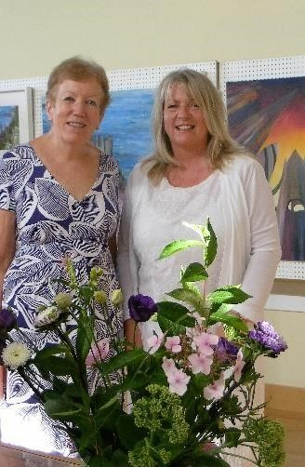
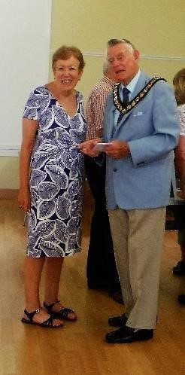
September 2016: NFAS Newsletter
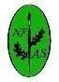

http://newforestartsociety.weebly.com/

Your Chair with Sandra Binney and Councillor Goff at the successful opening of the Summer Exhibition.

FACEBOOK.....thank you to the members who have joined. You are welcome to post. We will not put up individual members 'work' but we may use general pictures of events such as the summer exhibition.

October two day sale [: the paperwork has been sent by email (post for those without email address). If you have not seen it please check your junk box and give us a shout if you still can't find it. We are hoping for a successful two days.
Summer Exhibition 2016 Winners
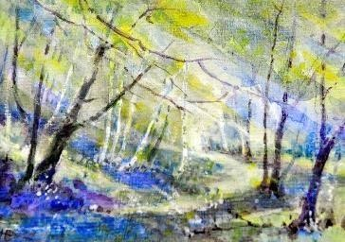

Pat Hatchley: Miniature

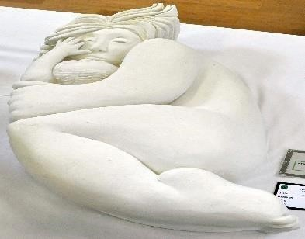

Edwin Beecroft: 3D
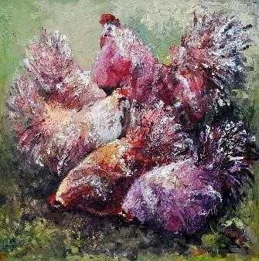

Colleen Cockroft: Representational
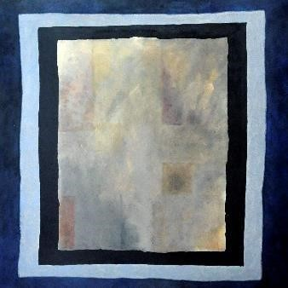

Sheila Taylor: Abstract
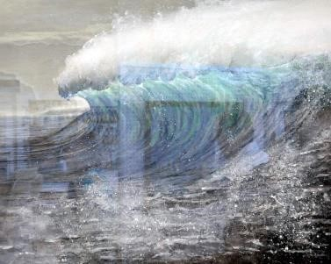

PUBLIC VOTES: we are please to announce that Shandy Simmons has done it again and won the most votes for her painting 'Tempest'. Brenda Wooller came second with 'To Pastures New' and joint third place was shared by Jenny Morgan for ' Mustang' and Sandy Poytner for
'Pulling Power'. The full list of votes will be available at the September meeting if members want to check out their own scores. [Exhibition Committee]

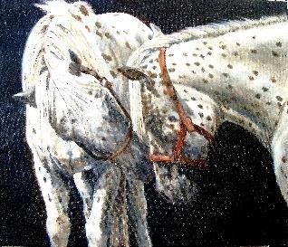
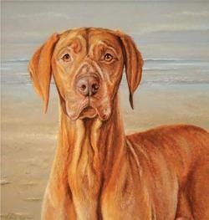
Sandy Poytner:
2
Guest Choice, Sandra Binney

Other members who were awarded Highly Commended:
Rosy Gould: The Meadow Autumn Art Sale 22nd – 23rd
Sandy Poynter: The Greeting
Sandra Morris: Wild Algarve October Lyndhurst
Susan Houching: Afternoon Tea
Joyce Livy: Langdale Early Spring Community Centre Linden
Room 10am – 4 pm
Big Thank You To: Rachael Smith [Chair of NFAS]… she
worked hard to advertise the event  and keep the exhibition committee an committee on track to a successful | d
summer exhibition. Thank You…
From Alli Goddard NFAS Sec
Brenda Wooller: Storm.

Next Meeting of
NFAS
Wednesday 14th September
7:30
Catherine Dunn: Pastel demonstration:
An animal study.

http://catherine-dunn.co.uk/ A
professional animal artist based in the beautiful New Forest, Hampshire with many clients throughout the UK and abroad. I have always had a great love for all animals, but
particularly horses and dogs and have been
lucky enough to combine this with a career in Workshop 8th October animal portraiture for over ten years. I am
dedicated to creating a portrait that is not only 10am-4pm Emery Down Hall a true likeness but one which captures the Artist: Sandy Poynter [member of the spirit and personality of each animal be it a society of equestrian artist] Cost: £25 rescue dog or a top level competition horse.
Taken from web site 22.08.16 Contact Brenda Molyneux for a place:
02380 844970
Cwmolyneux2@btinternet.com

1

September 2016: NFAS Newsletter

Any items for the October Newsletter
Send to Alli Goddard before 21st September: alliade1977@gmail.com

