9 March – 24 March 2024

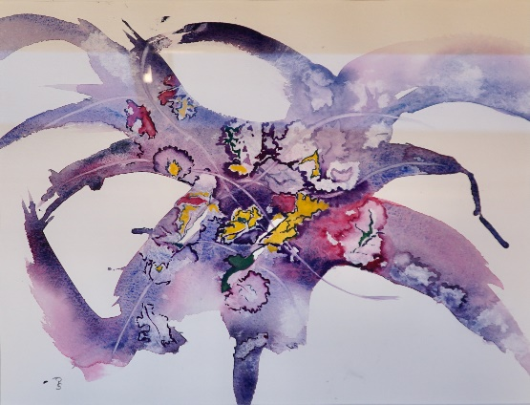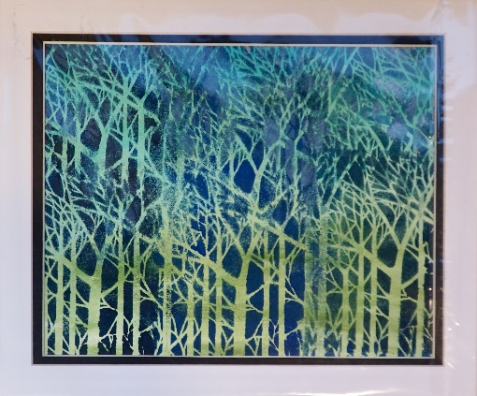

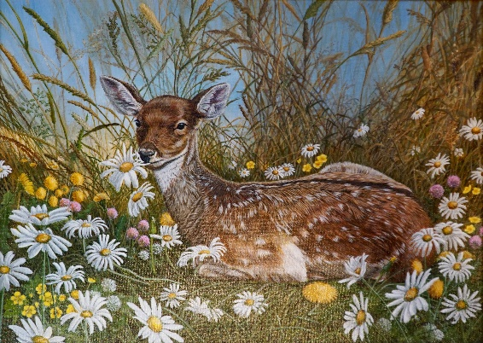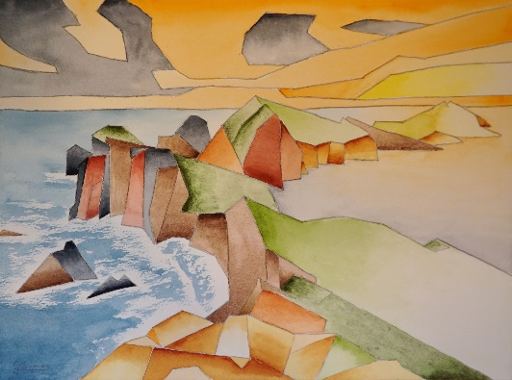

Sir Harold Hillier Gardens, Romsey, SO51 0QA
10 am – 4 pm* Free Entry to the Exhibition
*(Exhibition closes 3 pm on last day)

