Summer Exhibition

Our summer exhibition is well underway at the community centre in Lyndhurst and we will be delighted to see you should you visit. All our works look stunning against the walls of the Linden Hall, and were much admired at our reception on Saturday evening, when Maria Ragan from St Barbe Museum was our guest of honour. Our congratulations go to Pat Swain and Dot Lucas, whose works ‘Welcoming Tide’ and ‘Scots Pine’ were awarded her choice of best in show and highly commended respectively. The committee gave Alli Goddard their vote for her work ‘Rosso Paesaggio’ and highly commenced Brenda Molyneux for her work ‘Symphony of Colour’.

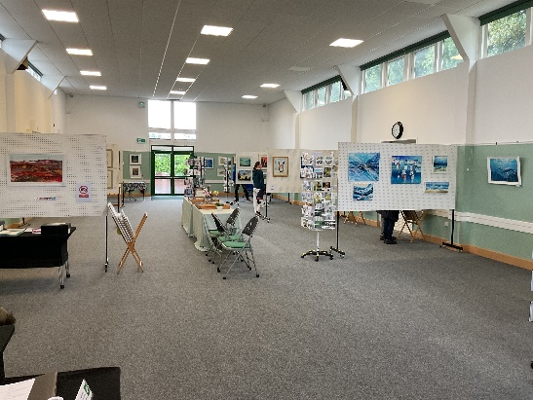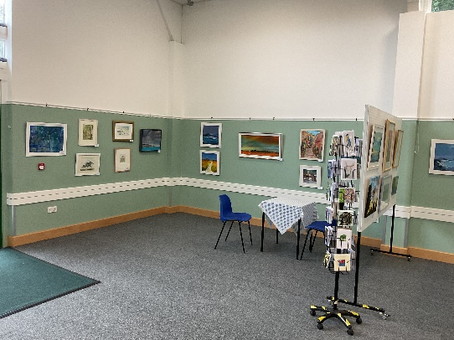

Margaret Plant offered a picture for the raffle which was won by Ruth Robinson, Rosy Gould won a voucher for a place on one of Teresa Rogers workshops, and Theresa won a piece of jewellery made by Caroline Bertram. Jakki Moore’s partner won a bottle of wine. It was a very enjoyable evening.
We have made several sales of framed works already, let’s hope this trend continues.

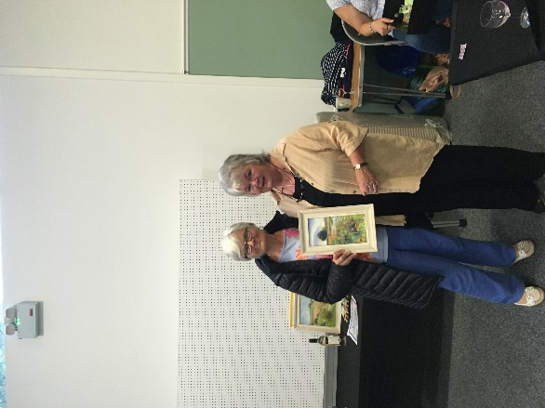
Ruth Robinson being presented with a picture by Margaret Plant

